ML Algorithms

- Multiple Regression (Mathematical Intuition):

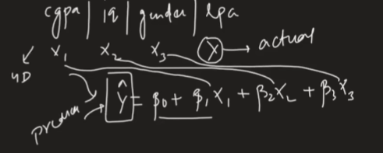

Representing the different features in formula

β1, β2, β3 and β0 is the c(y=mx+c)
the y^ is predicted and y is actual

Matrix Representation of predicted values:

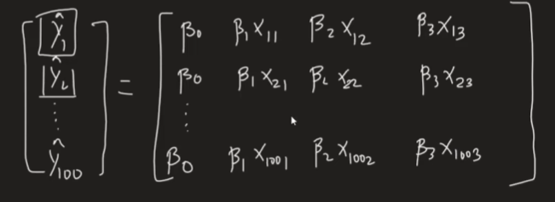

Now we know as we have found the formula therefore,
We have n rows and m columns

Therefore, Representation is in m and n

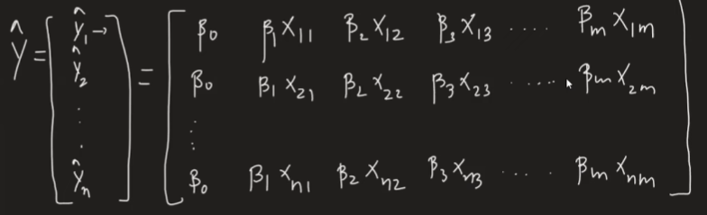

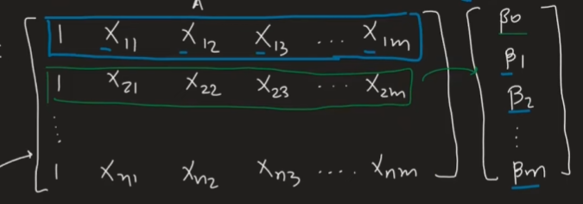

We will have y matrix with actual value of y
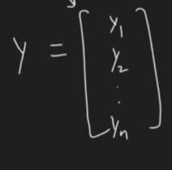

Now another matrix with difference of actual and predicted values
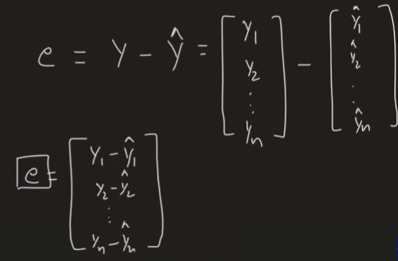

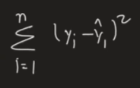
So e^{t} *e = as n simple linear Regression Error function

Proof:
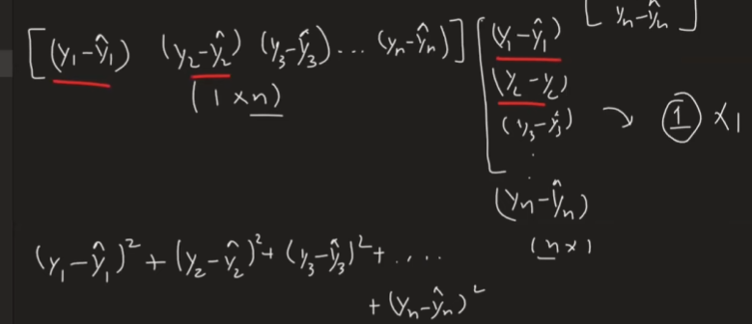

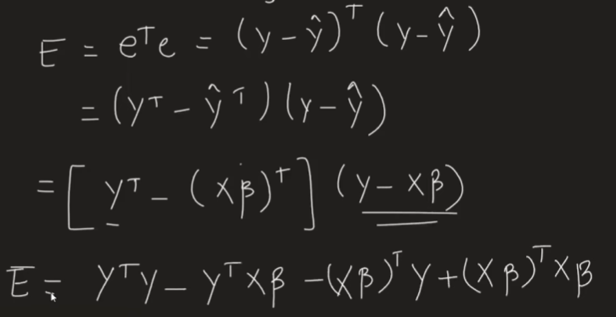

Now we will prove Y^{t} xβ = (xβ)^{t} Y

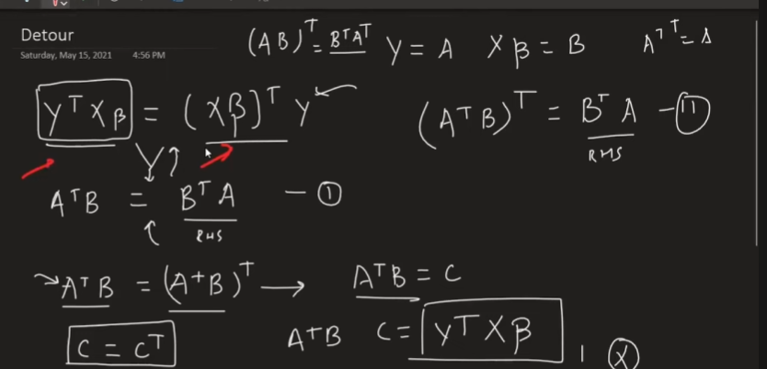
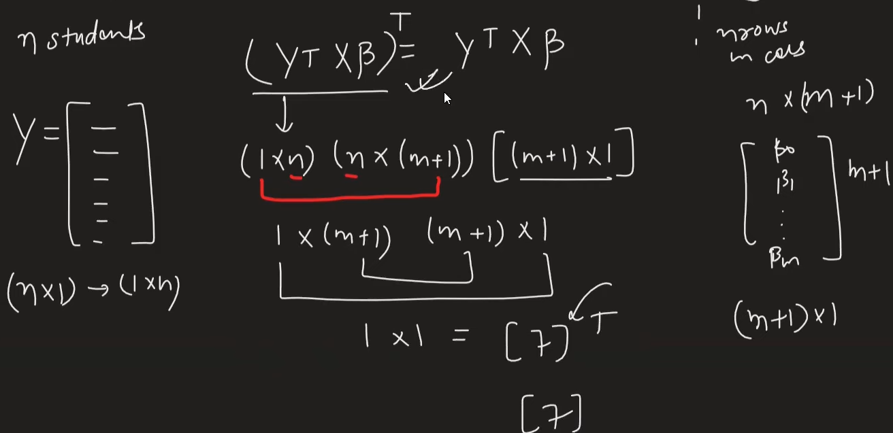
At last, we prove that: Y^{t} xβ = (xβ)^{t} Y

Now back to main Proof
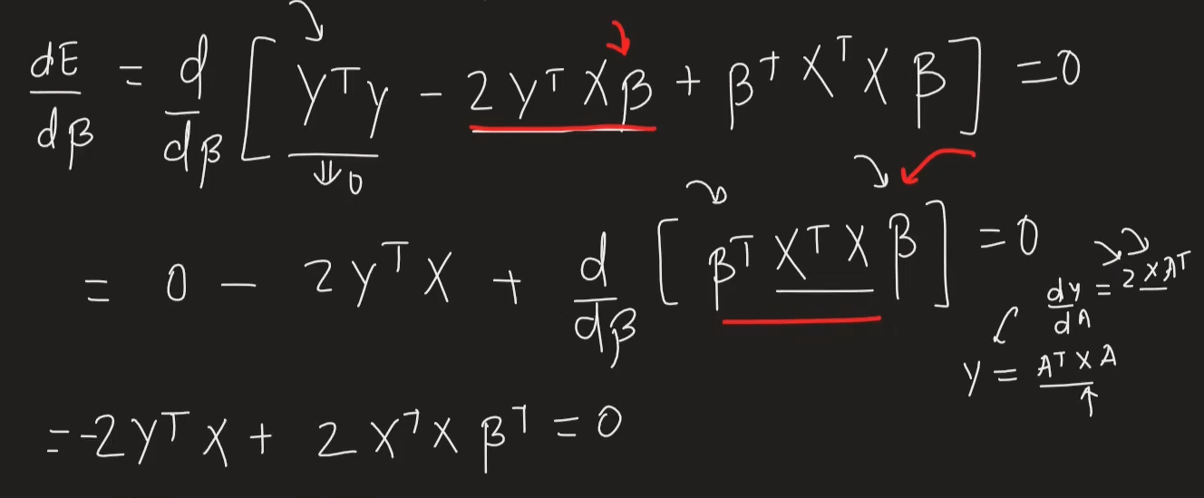

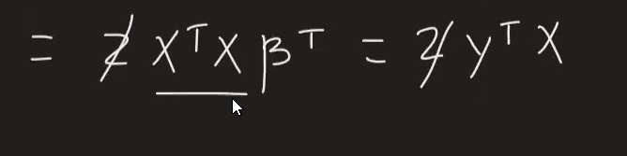

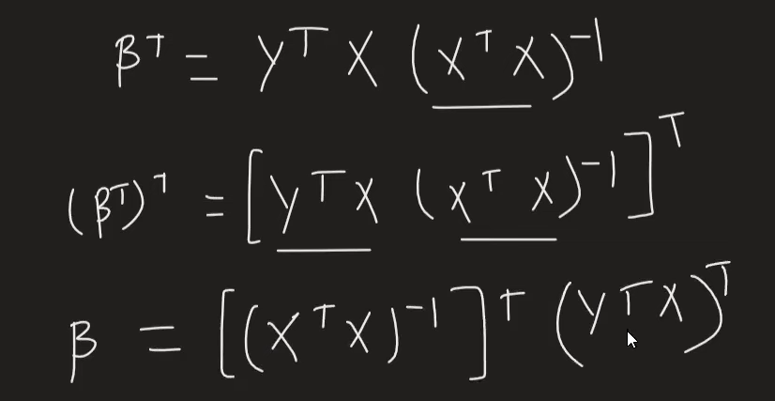
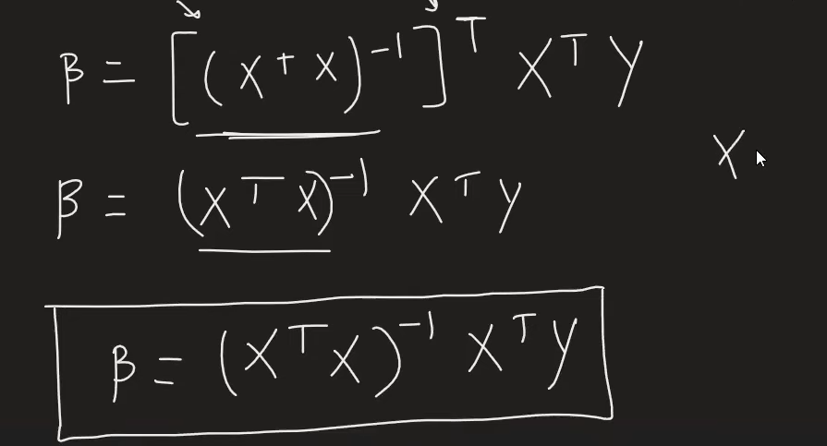

Here the x = X_train, y = y_train

Why Gradient Descent,
Cause OLS method will find the b values and give us prediction but
The computation cost of matrix inversion is very high O(n³) that’s why we use
Gradient Descent
